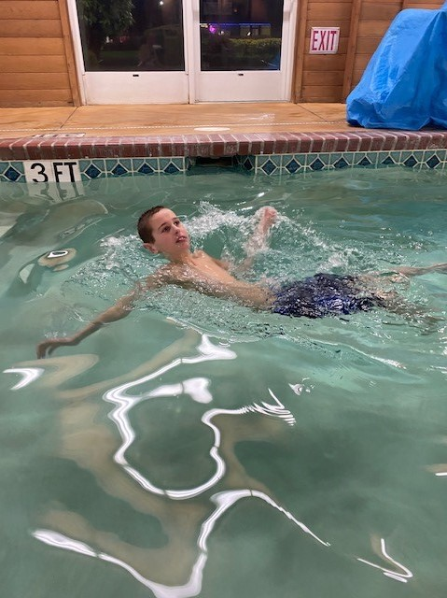

**Support I Need to Succeed**

* Full time, in person instruction
* Visual schedules, social stories, video modeling. I will need a lot of practice to get used to new safety routines and rules.
* Positive behavior supports to help me readjust back to school (which is different from the school I knew last year).
* Daily repetition to meet academic goals
* Social time with my peers
* Familiar adults and environments to regain the skills & routines I lost.

**How Covid 19 affected me**

I never went back to a safe, familiar routine after spring break 2020. All my routines of school, therapy, playing with friends, going to the pool suddenly vanished.

These routines helped me navigate my world, self-regulate and function. My world grew smaller and smaller and I became sadder and inconsolable.

My family has been very lucky that we have our home, good food to eat and a yard to play in. None of my family got sick and neither did I.

**Sam**

**2021/2022**

**Age 11**

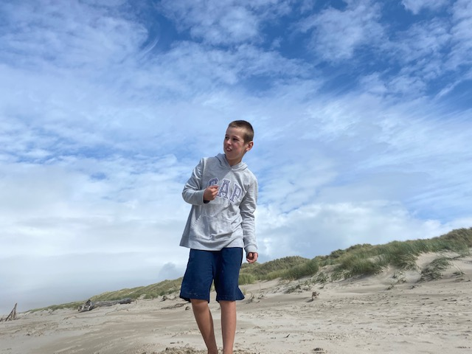

**What did not work this year**

* Online school. Zoom / videos cannot hold my visual attention for more than a few minutes at a time.
* Separation from my peers
* I'm very literal: school is not home and mom is not my teacher! This made the limited time I was on Zoom very frustrating.
* No routine; just being at home; too much screen time; no structure to my days
* Closure of familiar, regulating parts of my life like the pool, restaurants, movie theaters, parks, etc
* No social interaction with friends or family
* Not having a fluent communication method made online school very sad and frustrating. I felt very lonely.

**What Worked this year**

* Familiar routines in familiar environments; weekly & daily visual schedule
* Sensory regulation! All day long, sensory breaks/input allow me to regulate my body
* Model communication throughout the day using my AAC device; always have my device available.
* My IEP team created more age appropriate and challenging academic goals using my AAC device.
* Daily outside time: hiking, camping
* I learned to ride a bike and do chores at home.
* I got help from my doctor for my sadness. I am feeling better, though still very sad with the continued changes and limited routines.

